

Tribhuvan University
Faculty of Information Technology

A PROJECT REPORT
“SIGN LANGUAGE READER”

Submitted to
Department of BSc. CSIT
Bhaktapur Multiple Campus

In partial fulfillment of the requirements for the degree of Bachelor of Science in Computer Science and Information Technology

Submitted by
Arun Kumar Bhandari [symbol no.: 79010283]
Bishal Khadka [symbol no.: 79010289]
Ravi Kumar Sah [symbol no.: 79010317]

Under the Supervision of
Madan Nath
SUPERVISOR’S RECOMMENDATION
I hereby recommend that this project prepared under my supervision by Arun Kumar Bhandari, Bishal Khadka ,and Ravi Kumar Sah entitled “Sign Language Reader ” in partial fulfillment of the requirements for the degree of Bachelor of Computer Science and Information Technology, be recommended for the final evaluation.
---------------------------------
SIGNATURE
Madan Nath
SUPERVISOR
Bhaktapur Multiple Campus, Bhaktapur

LETTER OF APPROVAL
This is to certify that this project, prepared by Arun Kumar Bhandari, Bishal Khadka, and Ravi Kumar Sah entitled “Sign Language Reader” in partial fulfillment of the requirements for the degree of Bachelor of Computer Science and Information Technology has been evaluated. In our opinion, it is satisfactory in scope and quality as a project for the required degree.
----------------------------
Supervisor
Madan Nath
Lecturer
Bhaktapur Multiple Campus, Bhaktapur

-------------------------------
Sushant Paudel
Program Coordinator, BSc CSIT
Bhaktapur Multiple Campus, Bhaktapur

-------------------------------
Internal Examiner

-------------------------------
External Examiner

ACKNOWLEDGEMENT
We would like to express my sincere gratitude to my respected supervisor, Madan Sir, for his continuous guidance, invaluable support, and encouragement throughout the completion of this project entitled “Sign Language Reader”. His expertise and constructive feedback have been instrumental in shaping this report.
We are also thankful to the Department of Computer Science, Bhaktapur Multiple Campus, for providing us with the opportunity and resources to undertake this project as a partial fulfilment of the requirements for the BSc. CSIT program. The academic environment and facilities of the department have played a vital role in the successful completion of this work.
Our appreciation further goes to all our teachers at Bhaktapur Multiple Campus, whose teaching and guidance have greatly enhanced our knowledge and skills, as well as to our friends and classmates, for their cooperation and encouragement during different stages of the project.
Finally, we would like to acknowledge the authors and researchers whose works we have referred to and cited in this report, as their contributions provided valuable insights and a strong foundation for this study.
Regards,
Arun Kumar Bhandari [symbol no.: 79010283]
Bishal Khadka [symbol no.: 79010289]
Ravi Kumar Sah [symbol no.: 79010317]

Abstract
Water resources in Nepal are vital for agriculture, hydropower, drinking water supply, and disaster management, yet reservoir monitoring largely depends on outdated manual methods that suffer from inaccuracies, delays, and a lack of real-time data. This bachelor's project report proposes a technologically advanced Water Reservoir Monitoring System tailored to Nepal's challenging topography and climate variability. The system integrates Internet of Things (IoT) sensors (e.g., ultrasonic and pressure sensors), real-time data acquisition, cloud-based storage, predictive analytics, and user-friendly web/mobile dashboards to enable continuous monitoring of water levels, inflows, outflows, and critical thresholds.
Employing a Waterfall methodology, the study includes a comprehensive literature review, requirement analysis, feasibility assessment (technical, operational, economic, and schedule), high-level system architecture design, algorithmic framework, and planned implementation using tools such as HTML/CSS/JavaScript for the frontend, Python (Flask/Django) or Node.js for the backend, and microcontroller programming for hardware. The proposed solution supports automated alerts, historical data visualization, and scalability while addressing limitations of existing systems, such as human error and fragmented data management.
Although conceptual and limited to high-level design without prototype development or primary data collection, the project demonstrates strong feasibility and provides a practical roadmap for modernizing hydrological monitoring in Nepal. It emphasizes long-term benefits, including improved decision-making, flood/drought mitigation, resource optimization, and sustainable water governance, with recommendations for future enhancements like centralized data integration, early warning mechanisms, and community capacity building.

Table of Contents
List of Tables vi
List of Figures vii
List of Abbreviations viii
CHAPTER 1: Introduction 1
1.1 Background 1
1.2 Problem Statement 2
1.3 Objectives 3
1.4 Scope and Limitations 4
1.4.1 Scope 4
1.4.2 Limitation 4
1.5 Development methodology 6
1.6 Report Organization 7

List of Tables

No table of figures entries found.

List of Figures
Figure 1:American Sign Language Characters 1
Figure 2: Agile Development 6

List of Abbreviations
CNN=Convolutional Neural Network
ASL=American Sign Language

CHAPTER 1: Introduction

1.1 Background
Communication is one of the basic ways we, humans, convey information to one another to complete designated tasks. Talking is one of the basic forms of communication and is generally the first method that even infants use. But individuals with speech and hearing impairments are unable to communicate effectively with everyone. Options such as a professional sign language interpreter are extremely expensive to use regularly. Other preexisting systems include text-to-speech converters, which are useful but require the speaker to type, which can be cumbersome and not always possible.
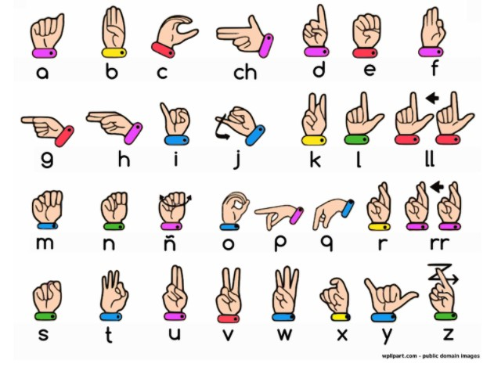
This project proposes a Real-time sign language to speech converter that can be used on a daily basis. This project uses computer vision, hand landmark detection and a Convolutional Neural Network (CNN) classifier. The project uses a camera to gather video information from which 21 key landmarks are separated via the MediaPipe framework (run through onnx), which extracts a skeleton-based feature representation and classifies it into one of 26 sign representations in the ASL. ASL is used as it is one of the few sign languages that uses single-hand representation of the alphabet, which is inclusive to the maximum number of disabilities and is easily recognized by Neural Networks trained on small data.
Figure 1:American Sign Language Characters
By using readily available hardware such as a camera (webcam), a screen, and open source software, we aim to provide a simple and practical software that can be easily deployed and used on a daily basis.

1.2 Problem Statement
The large global population of close to 70 million people, are suffering from conditions that make them unable to communicate effectively with the rest of the population. Most of them, while being capable of using sign language, do not use it because most normal people do not know sign language. These people thus rely on hearing aids and lip reading, which may be unreliable and costly at times and not only financially but through other means.

Although several research studies on sign language are openly available, they are not well-maintained leading to problems with their capabilities on a daily basis. Most of these systems require a high-end system and a knowledge of complex deep learning models to be installed which is not possible for most of the people as a majority of them are deaf due to problems regarding the age.

Therefore, we require a system that is designed to be lightweight yet robust so that it does not run into problems daily. We also require those systems to be diversely adaptable into multiple systems so that all easily available devices (laptops, mobiles, tablets, etc.) can run them.

1.3 Objectives
The main objectives of this project are:-
- To study existing hand language recognition systems ,and related techniques of reading and understanding the sign language.
- To design and implement a hand landmark extraction system using Google’s mediapipe and cv-zone for gesture recognition.
- To build and train a CNN model that can identify and understand ASL
- To make post-processing rules that can improve the accuracy of the system beyond the CNN output
- To implement a suggestion system that helps complete words using the PyEnchant Word dictionary
- To integrate text-to-speech functionality to convert words into sounds
- To make an intuitive and easy-to-use interface.
By achieving these objectives, we intend to make a standalone application that is easily usable in day-to-day interactions.

1.4 Scope and Limitations

1.4.1 Scope
The scope of this system is all the dumb, deaf people and normal people who find it hard to understand sign language or don’t know it at all. This system also aims at all the people with speech impairments as it has an embedded logic to try and guess what the user is trying to say. The production of output can also be done in terms of speech which allows for easy understanding even to illiterate people.

1.4.2 Limitation
Within the duration of the project, we ran into the following limitations.
- Time limitation
The amount of time was 6 months because of which we were unable to separate slack time for each part of the process. This resulted in lack of time for enough testing, optimization and smoothing.
- Resource limitation
We were limited by the amount of resources that were made available. We were not able to use special technologies such as motion capture, haptic gloves and such which reduced the reliability of our original test data.
- Restricted scope
The technology used for interpretation is exceptionally oriented in a straightforward way making it less usable in all cases. Our system only supports single-handed ASL which is not as good as it can be.
- Technical limitation
The system is highly dependent on the technology used so better technology highly changes the use cases and the implications of the system. We were unable to get hold of such technology making it difficult to make a perfect system.
- Accuracy limitation
The entire idea and system is dependent on the accuracy of it. Our system and others that it is based around have too low of an accuracy for regular use. Due to our data and other limitations, we were unable to raise the accuracy.
- User/use case limitation
The system is not easily usable by all people with varying levels of disabilities. The system is also not easily usable due to its requirement of device.

1.5 Development methodology
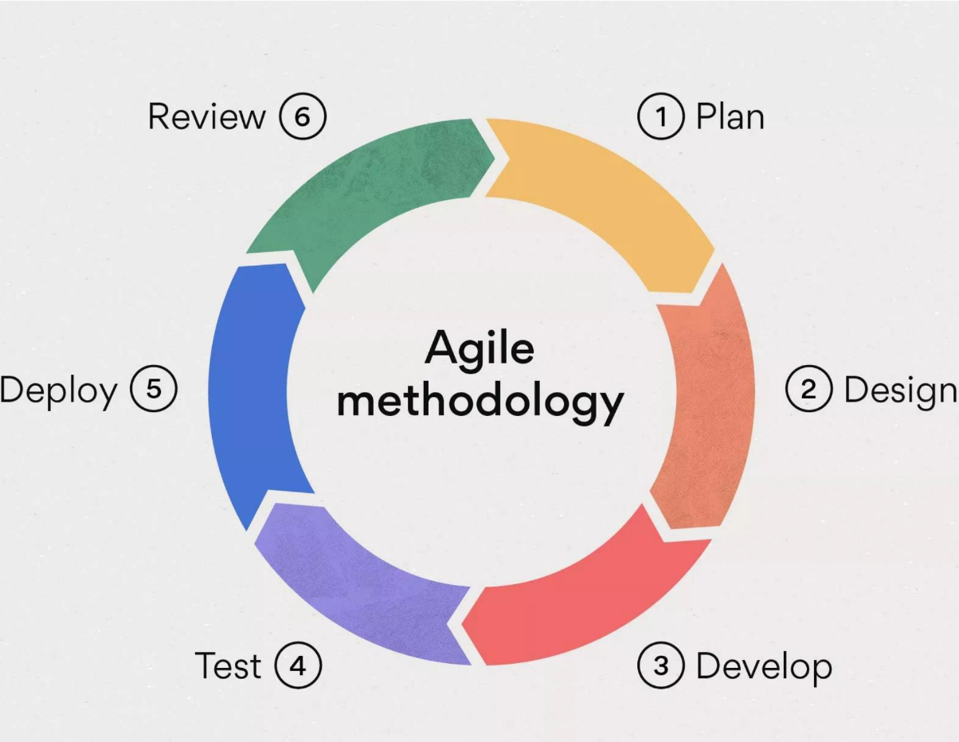
The software that we have developed was developed through the use of agile development methodology. Agile development is an incremental development approach that allows us to develop software with small increments of improvement. The development methodology allows for small changes based on feedback for iteration-based growth.
Figure 2: Agile Development
Steps of agile:
- Planning: This step is to gather the requirements and plan what we want to do.
- Design: We design the overall structure of the software logically.
- Develop: We code the system or build whatever is necessary for the functioning of the system.
- Test: We then test whether the system functions well in actual situations and whether any bugs are present.
- Deploy: We finally put the system to use in the environment.
- Review. This step focuses on observing the system and finding defects that are put back into development to solve.
The entire process then starts again until we are satisfied with the product.

1.6 Report Organization
This section provides a brief outline of the structure of the report.
Chapter 1: Introduction – Overview, outline, scope, limitations, and the objectives of the report.
Chapter 2: Literature Review – review of related works, background theory, and the references of the project.
Chapter 3: System Analysis – Analysis of the requirements for the system and its logical structure.
Chapter 4: System Design – Logical and physical design of the system along with the description of the algorithms used in it.
Chapter 5: Implementation and Testing – Presentation of the code, project work, output and analysis.
Chapter 6: Conclusion and Future Recommendations – Final summary of work and findings, and recommendations of the system.

CHAPTER 2: Background Study and Literature Review

2.1 Background Study
This project is developed in the domain of computer science, in order to solve real-life problems of communication between speech-impaired individuals. This system uses a simple theory in its development. It uses the following bodies for its implementation:
- TensorFlow-Keras and OnnxRuntime
This is the main system behind the machine learning capability of the system. TensorFlow is a MAL with deep learning with cross-platform scalability. Keras is a high-level API of the TensorFlow system that simplifies the process and makes it easy to access other TensorFlow systems.
Onnx is a system of generative AI that can connect software with model generation to make it easier to both produce and use models. OnnxRunTime is the system of Onnx that uses existing models to connect to the video feed of the software.
- CV Zone
CVzone, also known as Computer Vision zone, is a system that allows any computer to see and recognize objects with the help of its camera. Here in the project we are Hand Tracking Module from CVzone to track the joints of the hand.
- Pyttsx 3
This is a module that is capable of converting text to speech in a python code. It is used by the system to produce sounds.
- PY Enchant
Enchant is a dictionary that can be used on English words to suggest spellings and corrections to the words. It is used here due to the lack of accuracy of the system allowing it to produce correct results.The system uses a separate model to collect information as if it were to collect information during runtime then it would use a lot more space and time for calculation.

2.2 Literature Review

